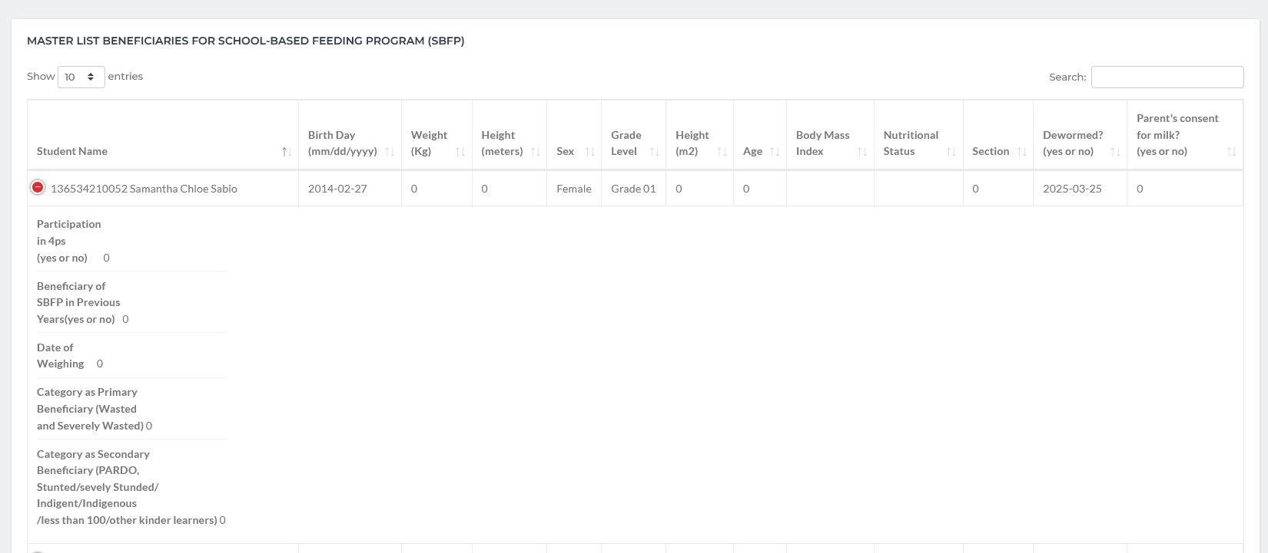
SBFP Data
- Student Name (Last Name, First Name MI) order by Last Name
- How is the editing of Weight, Height and Height (m²)?
- Computation of BMI
- Nutritional Status should be automated
- Section should be the actual section of the student
- Dewormed? Should be Yes and No only. How to input this?
- There should be an editing of Enrollment specifically for the Height, Weight, Age, Dewormed, Parent’s consent for milk, Participation in 4ps, Beneficiary of SBFP in Previous Years, Date of Weighing)

Baseline Weighing
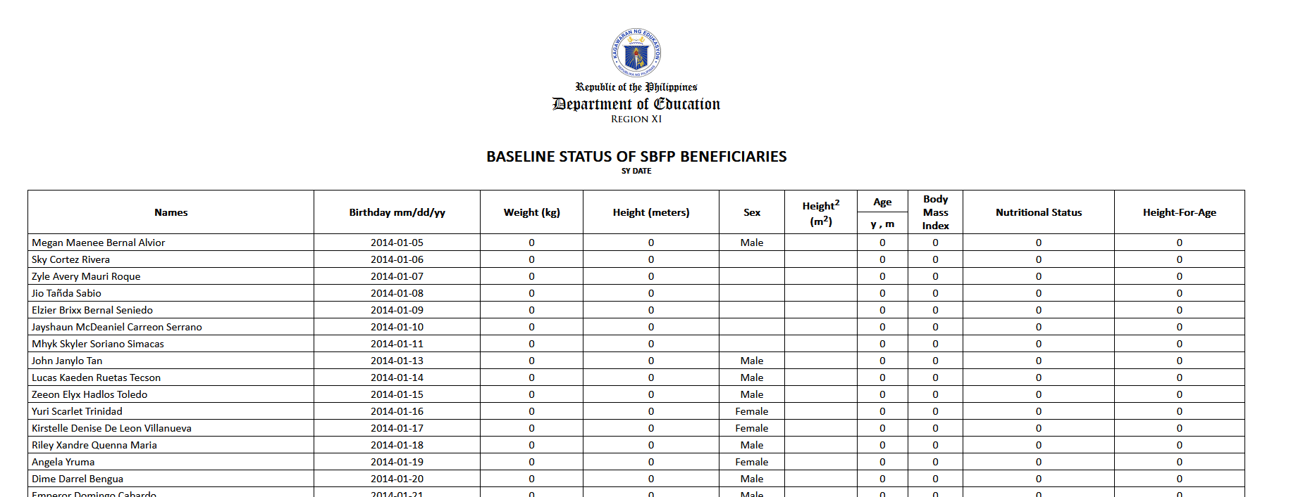
- Format of the date should be according to the format mm/dd/yy
- Age value (y, m)
- Nutritional Status should be automated according to the value of BMI
- For the meantime, leave the Height-For-Age to empty.

In the summary part:
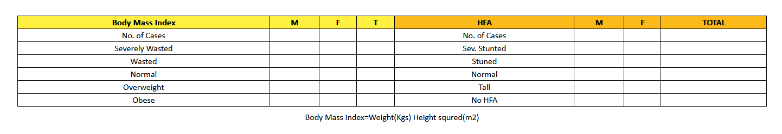
- Reflect the summary at the bottom part.
- Automate the SF8 values. It should be printable.

